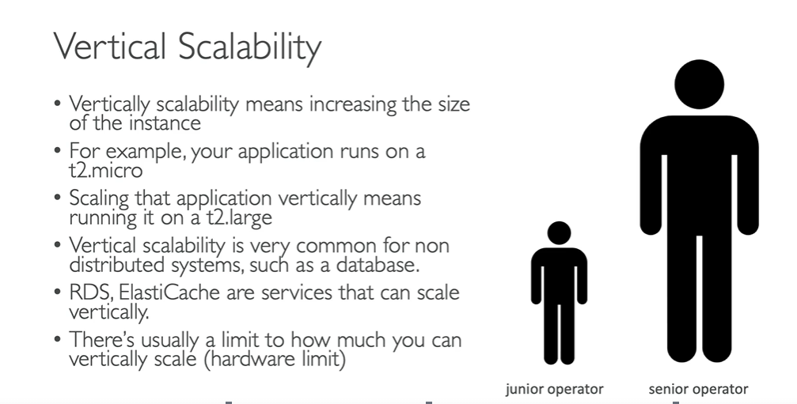

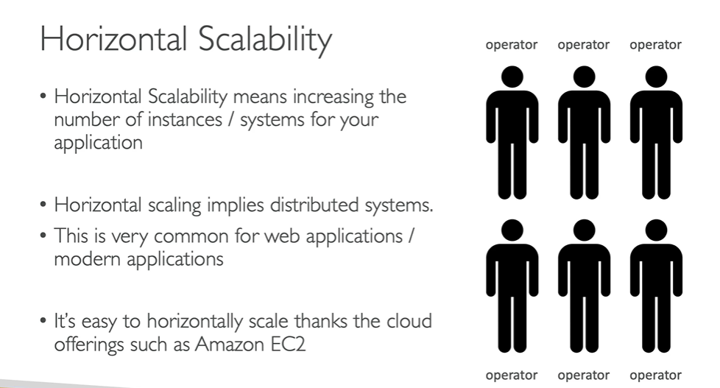

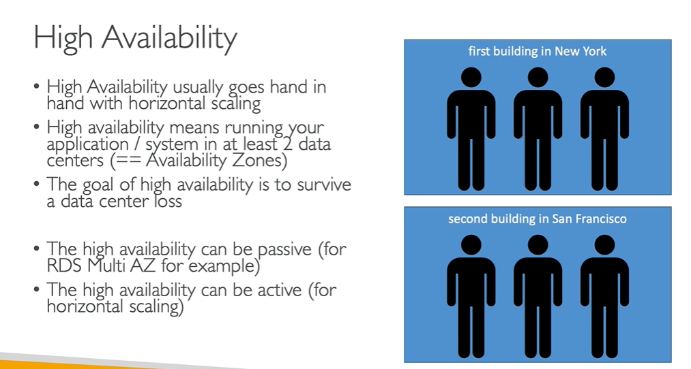

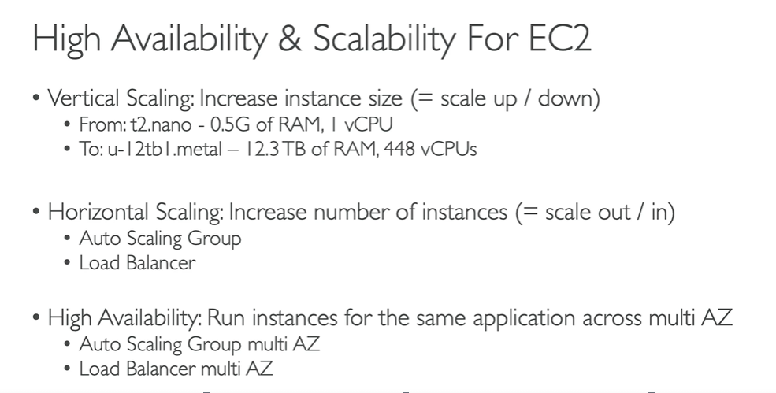

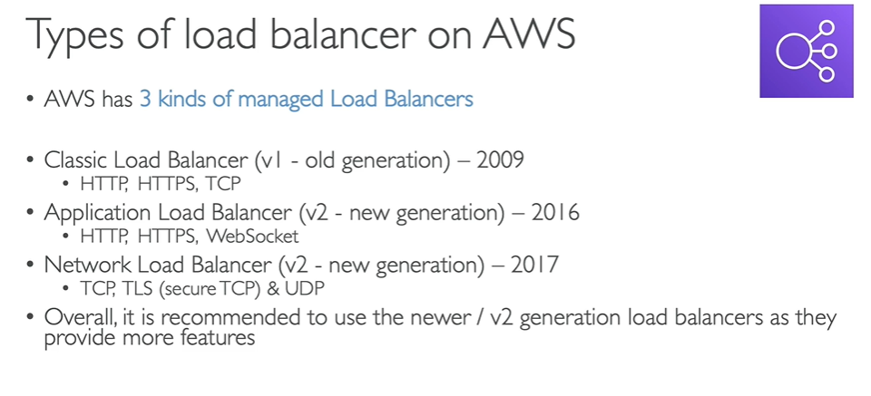

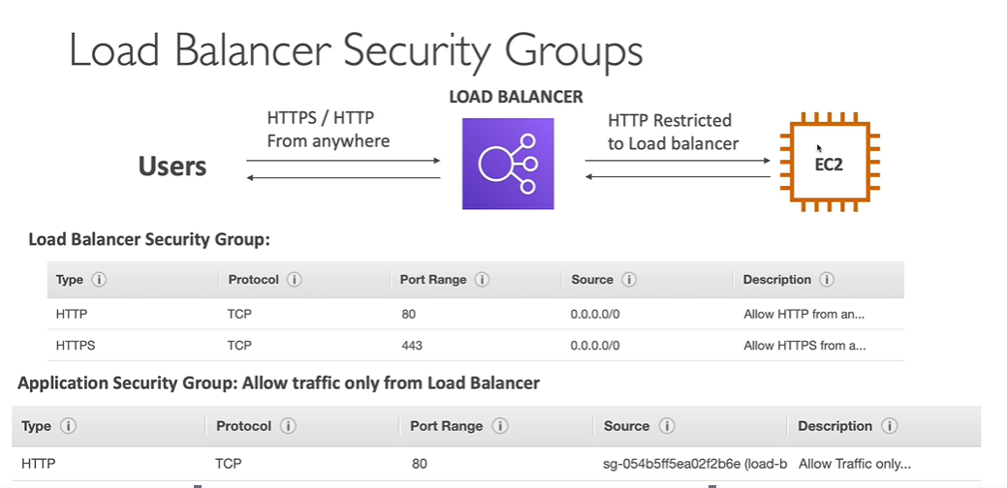

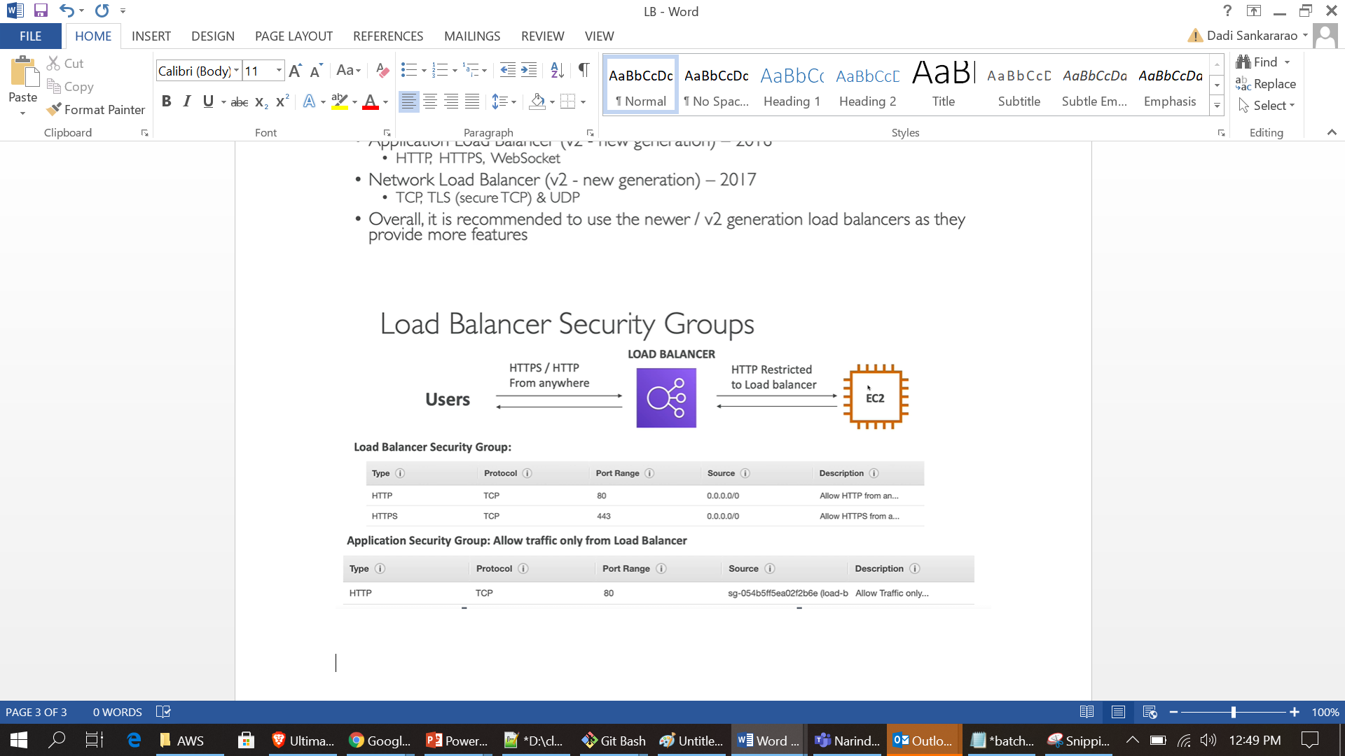

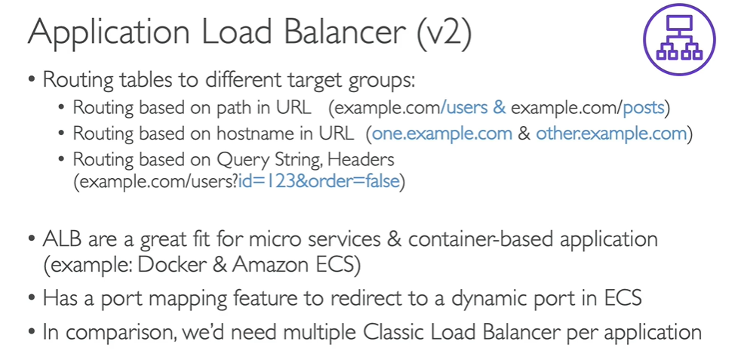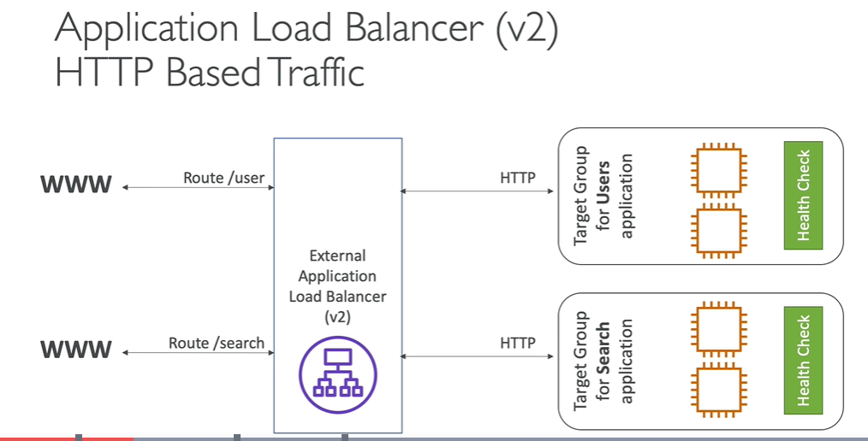

ALB Setup:

Create two instances, install apache on both the machines, and create credit and debit folders under/var/www /html folders of the instances and place index.html file under the credit and debit folders of the servers.

Ex : /var/www/html/credit/index.html

/var/www/html/debit/index.html

Create Target groups and add instances to the target group:

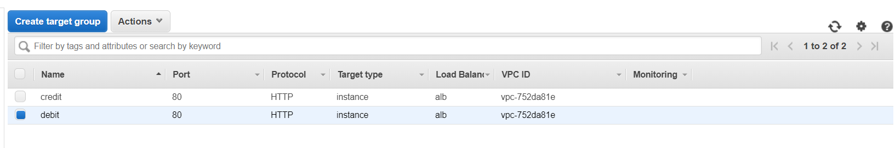

Create ALB with default routing (if no path mentioned it will go to default)

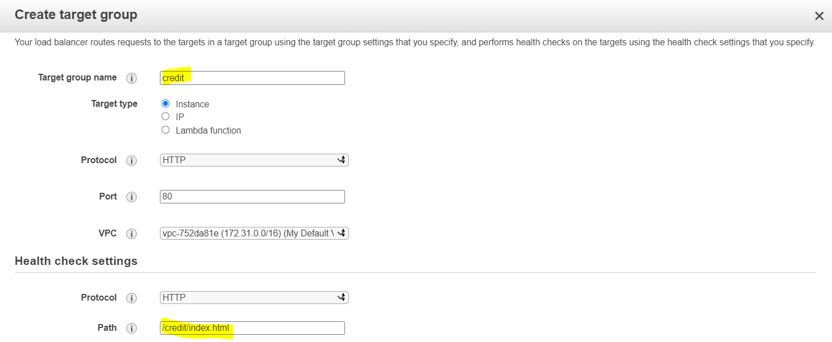

**Create Rule(click on view/edit rules)**

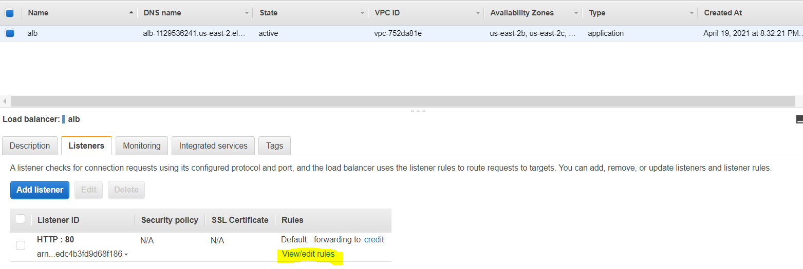

**Add the rules for routing (example: if path is /credit forward to one of the target group)**

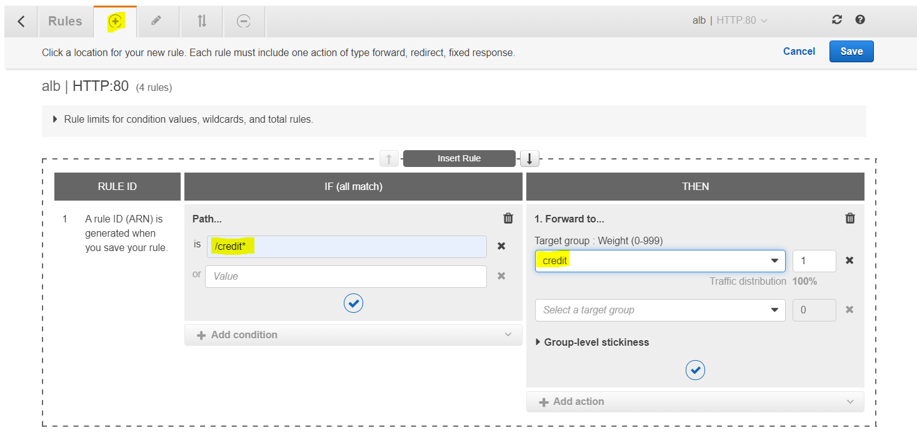

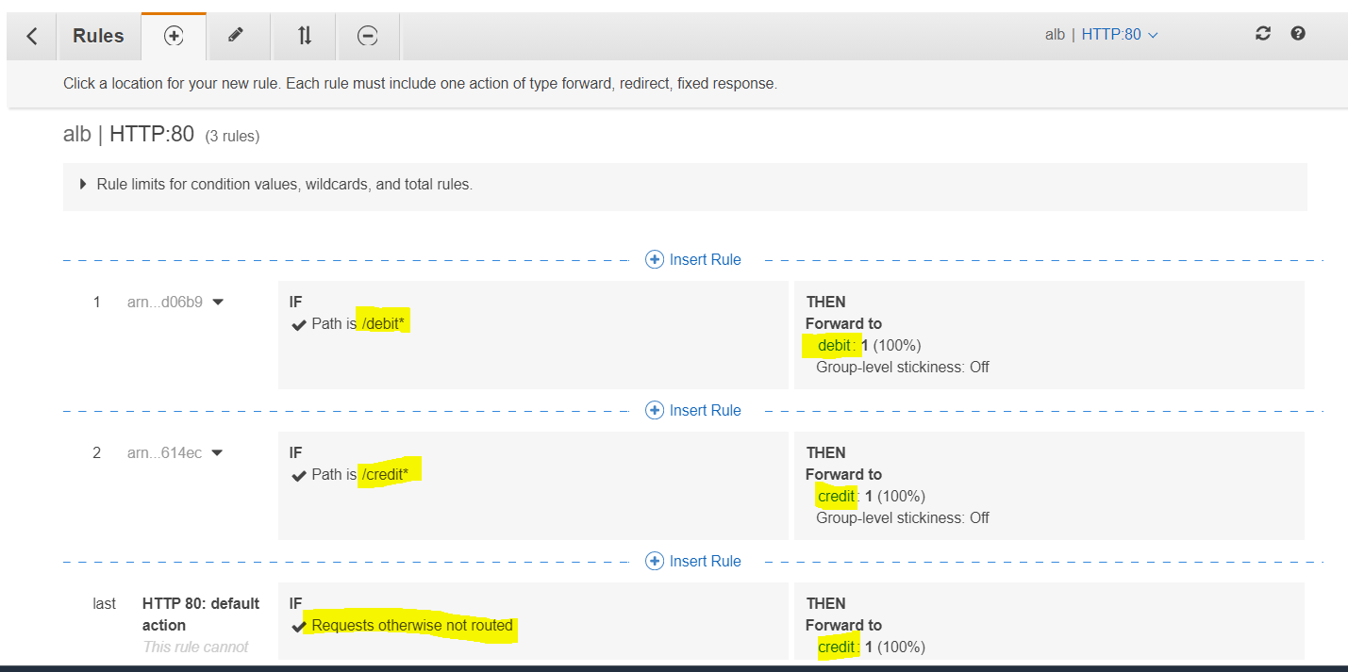

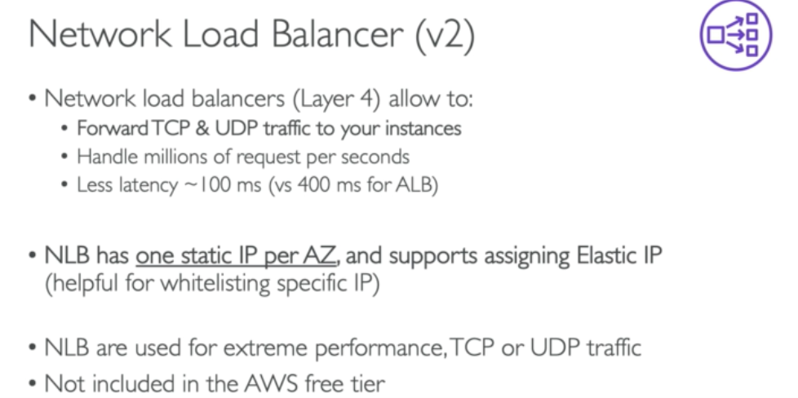

Create NLB with protocol TCP (it is not free service)

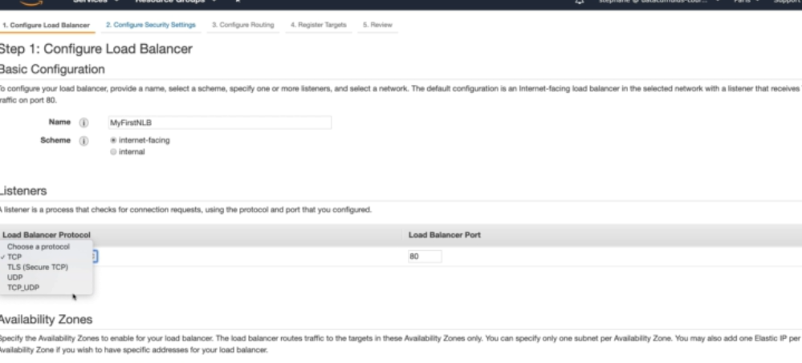

Attach target group(if already exist , else create new one and add the instances to the group)

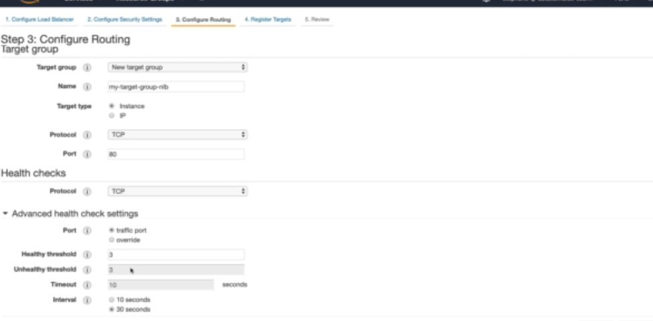

NLB uses the tcp traffic, due to the reason application will not be accessible , open the tcp port of the instances security group to access the app outside.

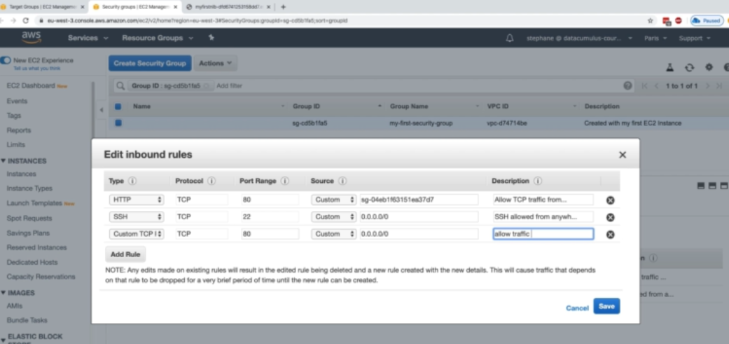

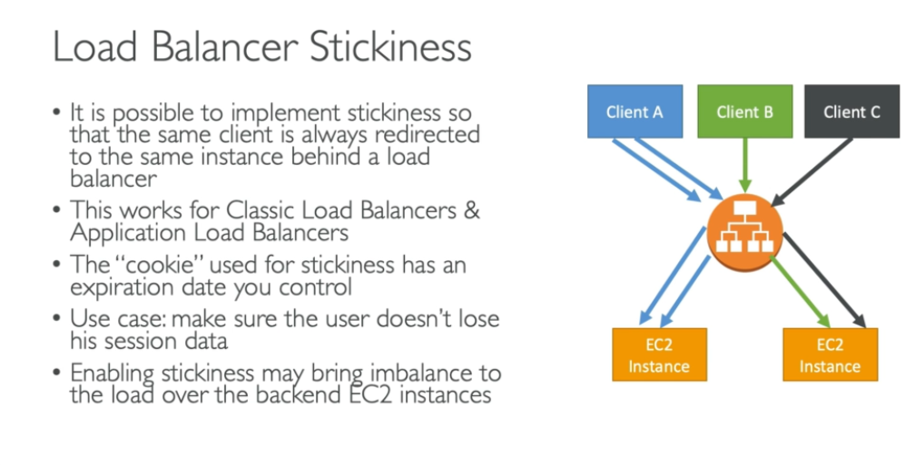

To enable stickiness:

Go to load balancer attributes(scroll down) , you will find stickiness is disabled to enable it click on edit attributes

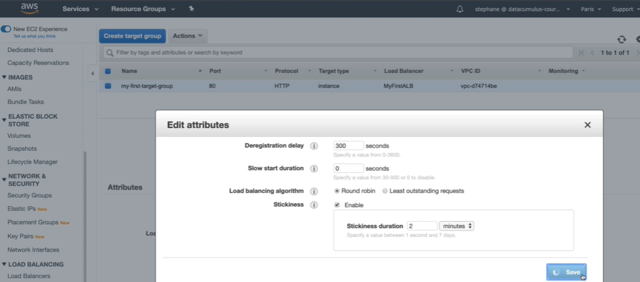

Wait for some time to activate the changes, now test it , request will go to same server until the client session is active for 2minutes minimum

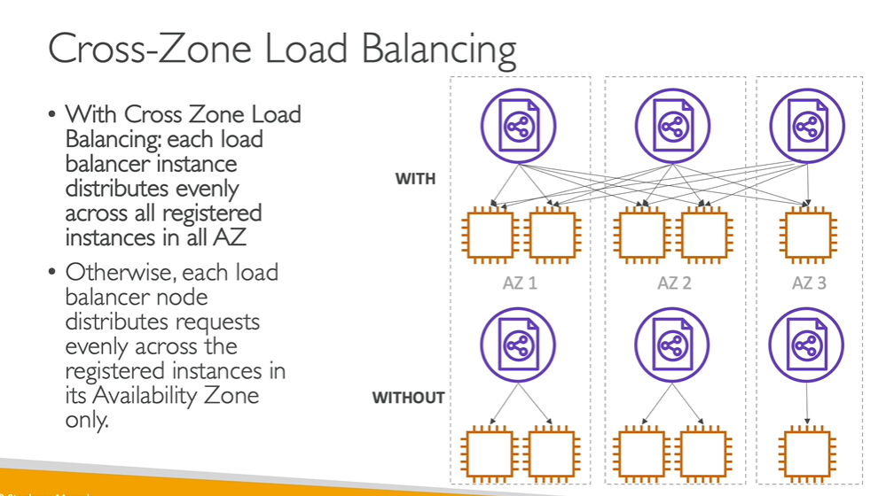

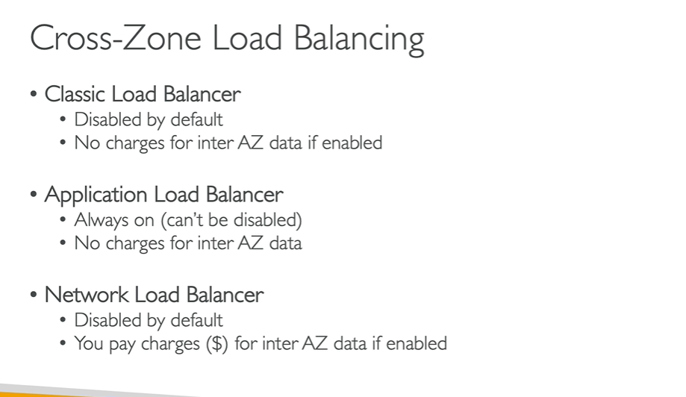

Classic Load Balancer: (to enable go down to the attributes)

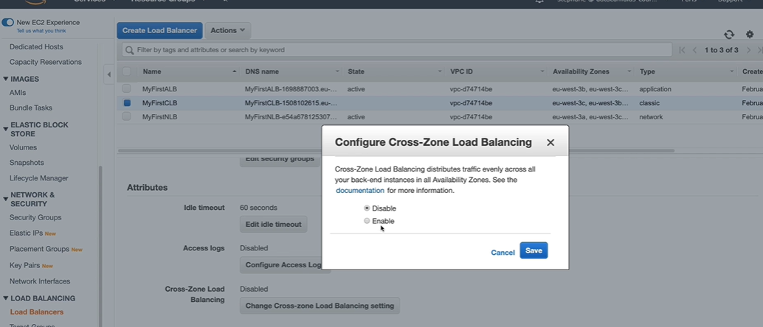

For NLB: (charges)

